|  |  |
| --- | --- |
| EGC_Black | Student Name \_\_\_\_\_\_\_\_\_\_\_\_\_\_\_\_\_\_\_\_\_\_\_  **Eastern Goldfields College**  Mathematics Methods Year 11 2017  Assignment Validation – Calculator Free |
| Working Time: 10 minutes | Total Marks: 10 marks |

**Question 1 (4 marks)**

Given that $4sinθ-3=0 and 0°≤θ≤90°$, determine the exact values of the following.

**(a)** 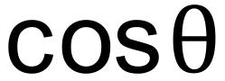 (2 marks)

**(b)** 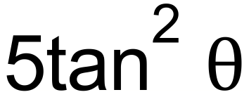 (2 marks)

**Question 2 (6 marks)**

**(a)** Determine the exact value of 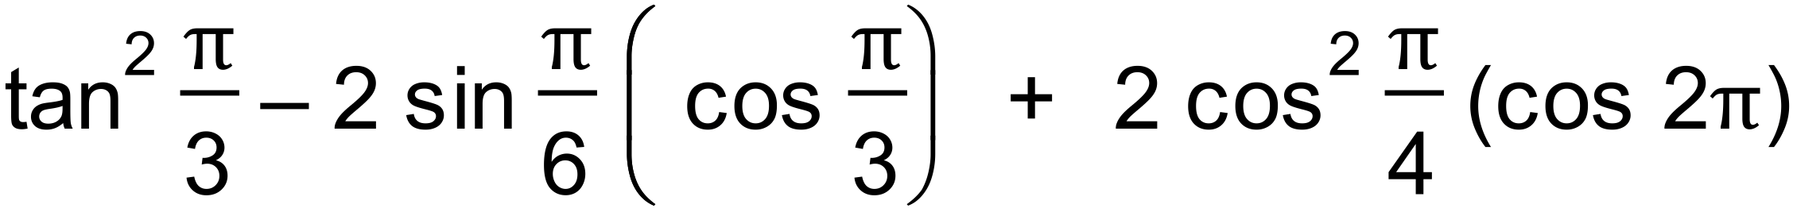 (3 marks)

**(b)** If $sin3A= \frac{1}{2}$, find the value of A, given that 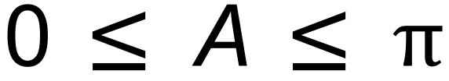. (3 marks)

|  |  |
| --- | --- |
| EGC_Black | Student Name \_\_\_\_\_\_\_\_\_\_\_\_\_\_\_\_\_\_\_\_\_\_\_ |
| EGC_Black | Student Name \_\_\_\_\_\_\_\_\_\_\_\_\_\_\_\_\_\_\_\_\_\_\_  **Eastern Goldfields College**  Mathematics Methods Year 11 2017  Assignment Validation – Calculator Assumed |
| Working Time: 20 minutes | Total Marks: 20 marks |

**Question 3 (8 marks)**

**(a)** Shade the following expressions on the Venn diagrams given below.

(i) (A $∩$ B) $'∪$ (A $∩$ C) (2 marks)

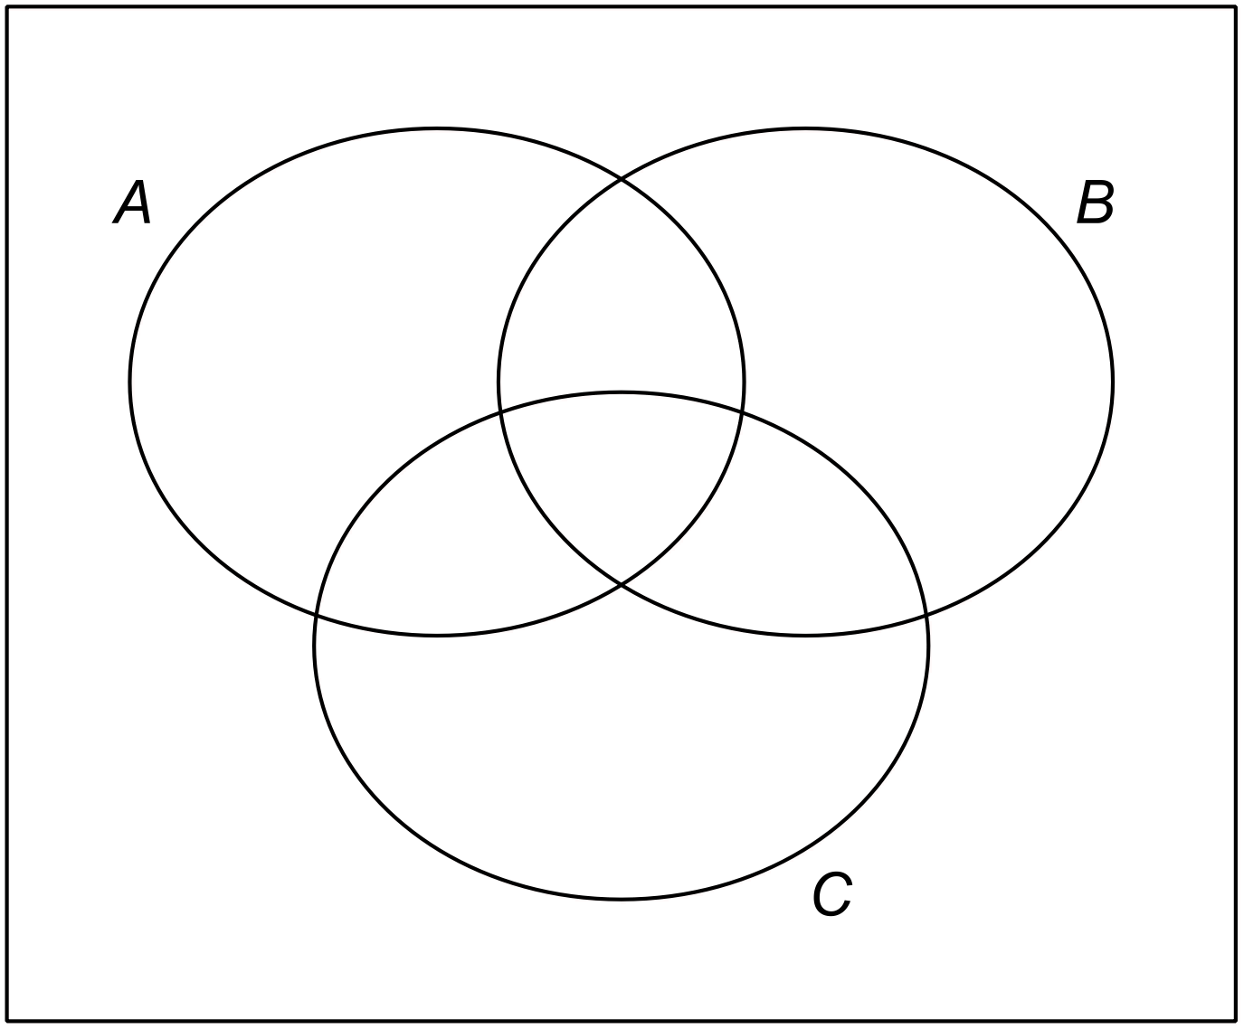

(ii) (A $∪$ C) $∩$ B (2 marks)

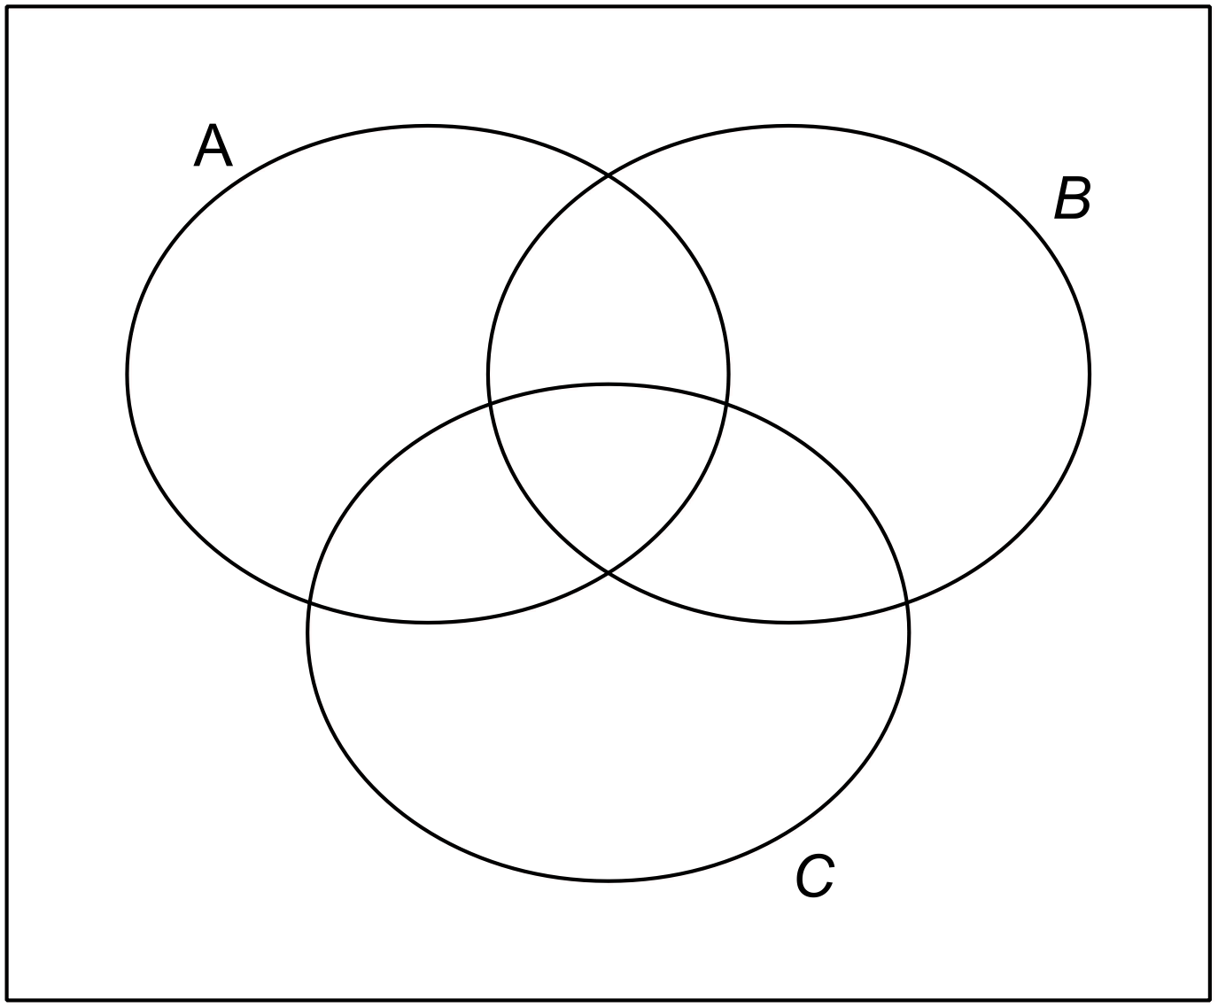

**(b)** Consider the probabilities presented in the Venn diagram below.

U

*A*

0.1

*B*

0.6

0.3

1. Complete the two-way table below to represent the same information given above.

(2 marks)

|  |  |  |  |
| --- | --- | --- | --- |
|  | A |  | Total |
| B |  |  |  |
|  |  |  |  |
| Total |  |  |  |

(ii) Determine P( 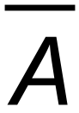 $∪$ 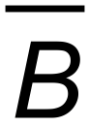 ) (1 mark)

(iii) Determine P(B | A) (1 mark)

**Question 4 (12 marks)**

Consider the graphs below.

**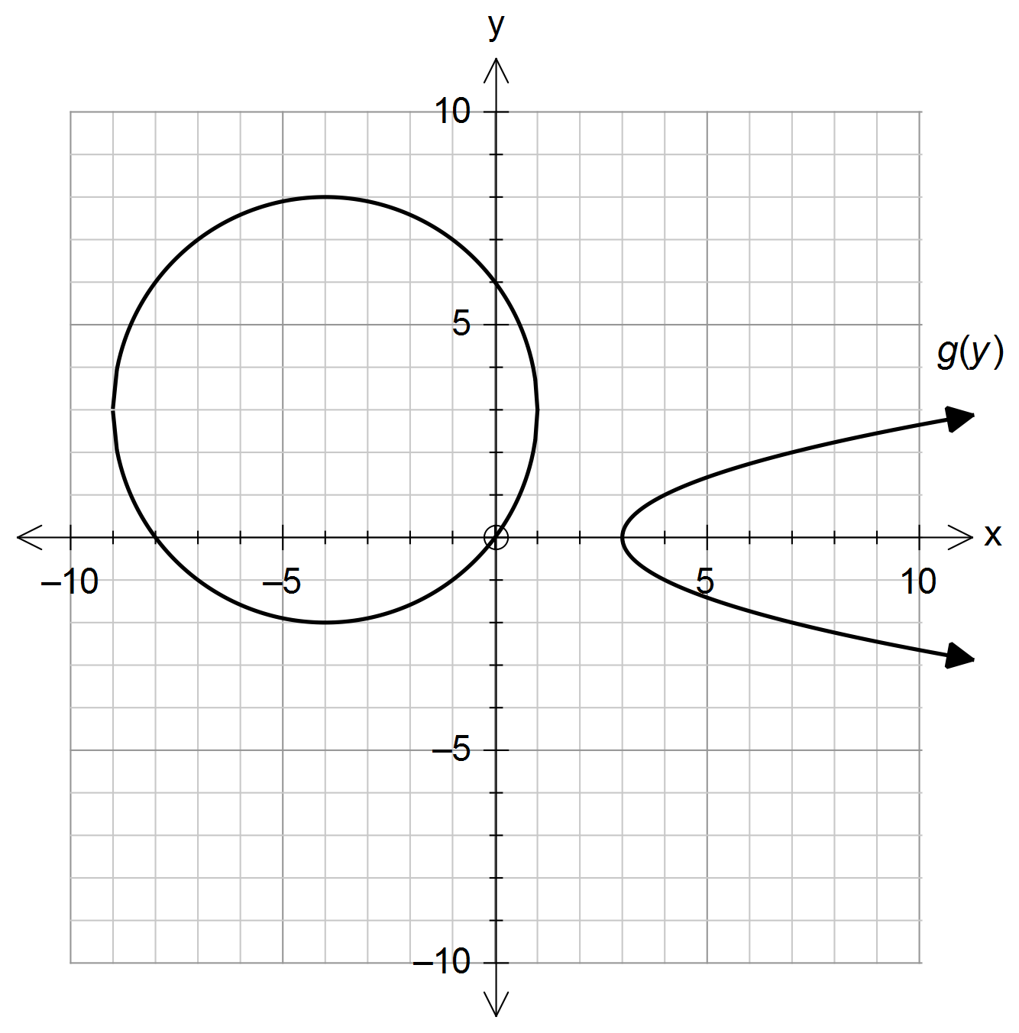**

**(a)** (i)State the equation of the circle in the form 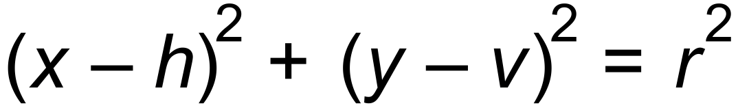.(2 marks)

(ii) State the domain of the circle. (1 mark)

**(b)** Determine the centre and the radius of the circle with the equation

**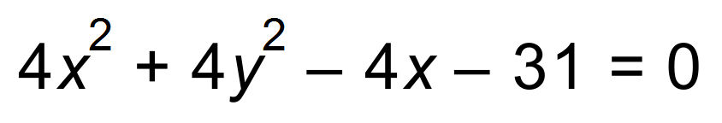**.

(3 marks)

**(c)** (i) State the equation of the graph of the relation 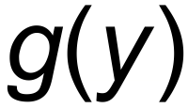. (2 marks)

(ii) State the range of 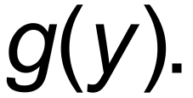 (1 mark)

(iii) State the equation for the axis of symmetry of g(y). (1 mark)

(iv) The relation, g (y), can be stated as two functions combined. State the equation of the negative function and the restriction on the range to obtain this function. (2 marks)